

**Paradise**

**Chaser**

Online Travel & Tours Agency

User Manual

University of

Technology Mauritius

*School of Innovative Technologies*

*and Engineering Department of*

*Business Informatics and Software Engineering (SITE)*

Module Name : System Development Project

Module Code : PROJ3105C

Programme : BSc (Hons) Web Technologies

Supervisor Name : Mr. A.Tulsi

Student Names & ID : AUCKBARAULLEE Fardin (160285)

Student Cohort : BWT16AFT

Submission Date : 16.05.2019

This dissertation is submitted in partial fulfilment of the requirements for the degree of Bachelor of Science with Honors in Web Technologies

**System Configuration**

Software Required to launch web application

1. Xampp

XAMPP installation can be downloaded from the following website <https://www.apachefriends.org/download.html>

Steps to setup XAMPP:

1. 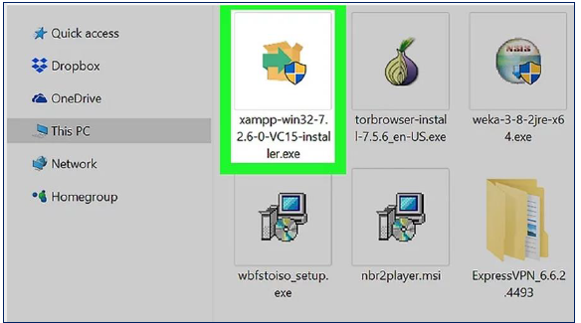Run the Xamp exe file on your computer
2. Select the components you want to install, in our case, we select all of them as precautionary measures.

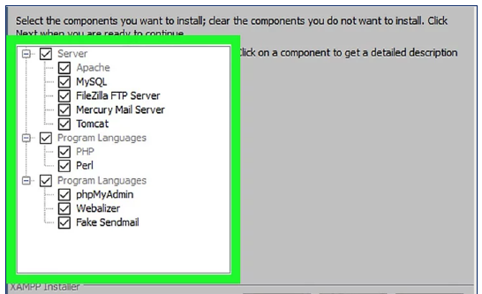

1. The next step is to click on the ‘Next’ button. A screen will appear asking which directory to install the program. By default, it is **‘C:\xampp’**, however this is can be modified to your desired directory.

After the ‘Next’ button, the following screen will appear:

It is advisable to uncheck it unless you want to learn in dept about XAMPP. This is optional.

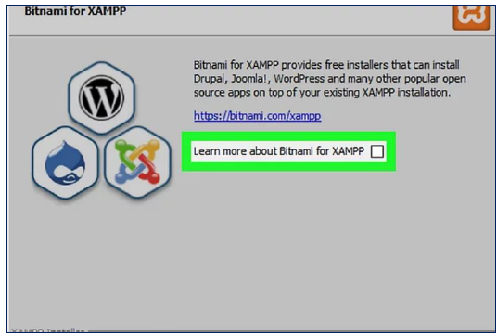

1. The program will now be installed and upon clicking on the ‘Finish’ button, a pop up will appear asking the language of the program in which to display.

Select your preferred language (most used: English) and click on ‘Ok’.

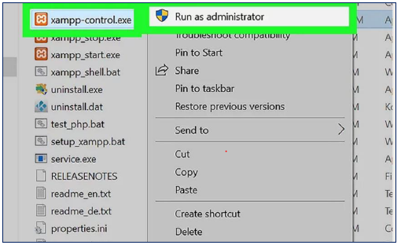As shown in the figure below, open the ‘xampp-control.exe’ with admin rights:

1. Once configured, the following control panel will appear, start Apache and MySQL only.

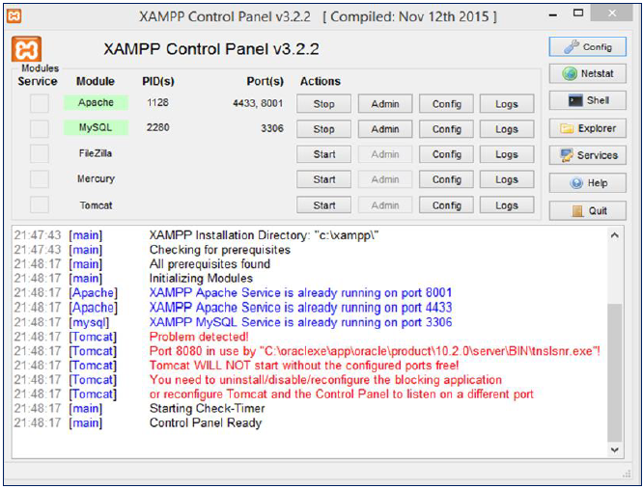

1. Phpmyadmin

Phpmyadmin is the repository where your database will be stored.

Steps to configure database:

1. Open your web browser and type in localhost followed by your port number for example, localhost:8000 or localhost:1234 or localhost:2646. If you are not sure about your port number, please see figure below to locate yours:



Once you entered <http://localhost:8001/> on your web browser, the following is displayed:

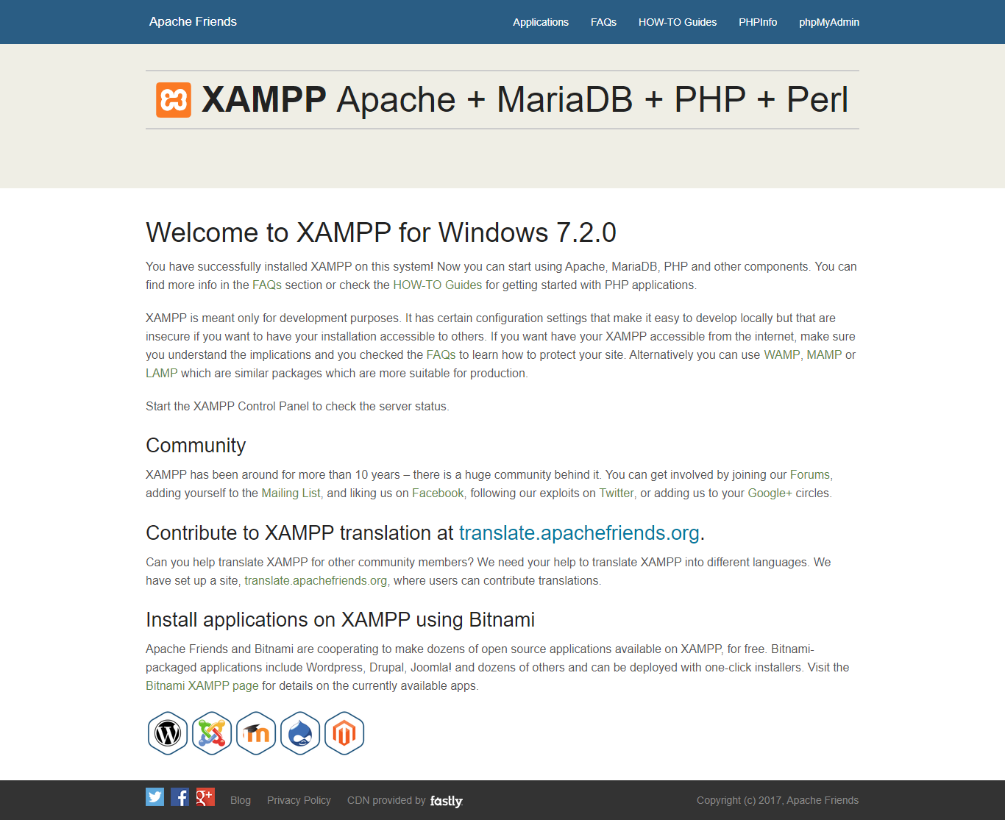

Select phpMyAdmin on the top right corner of the page and the following will be displayed:

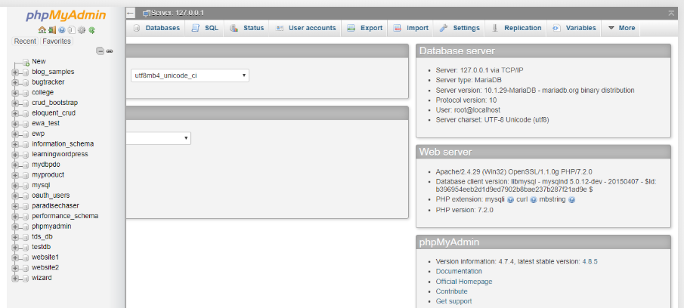

To create your database, click on **New** and type in “**paradisechaser**” as the database name, then go to **Import** and choose the file ***paradisechaser.sql***

After having successfully setup your database, go to **C:\xampp\htdocs** on your computer and copy the OnlineTravelTours folder there.

You have completed the configuration for your web application. It is now time to access the web application through any web browser.

To access paradisechaser, type in [http://localhost:**YOURPORTNUMBER**/OnlineTravelTours/](http://localhost:YOURPORTNUMBER/OnlineTravelTours/)

Paradise Chaser homepage will be displayed:

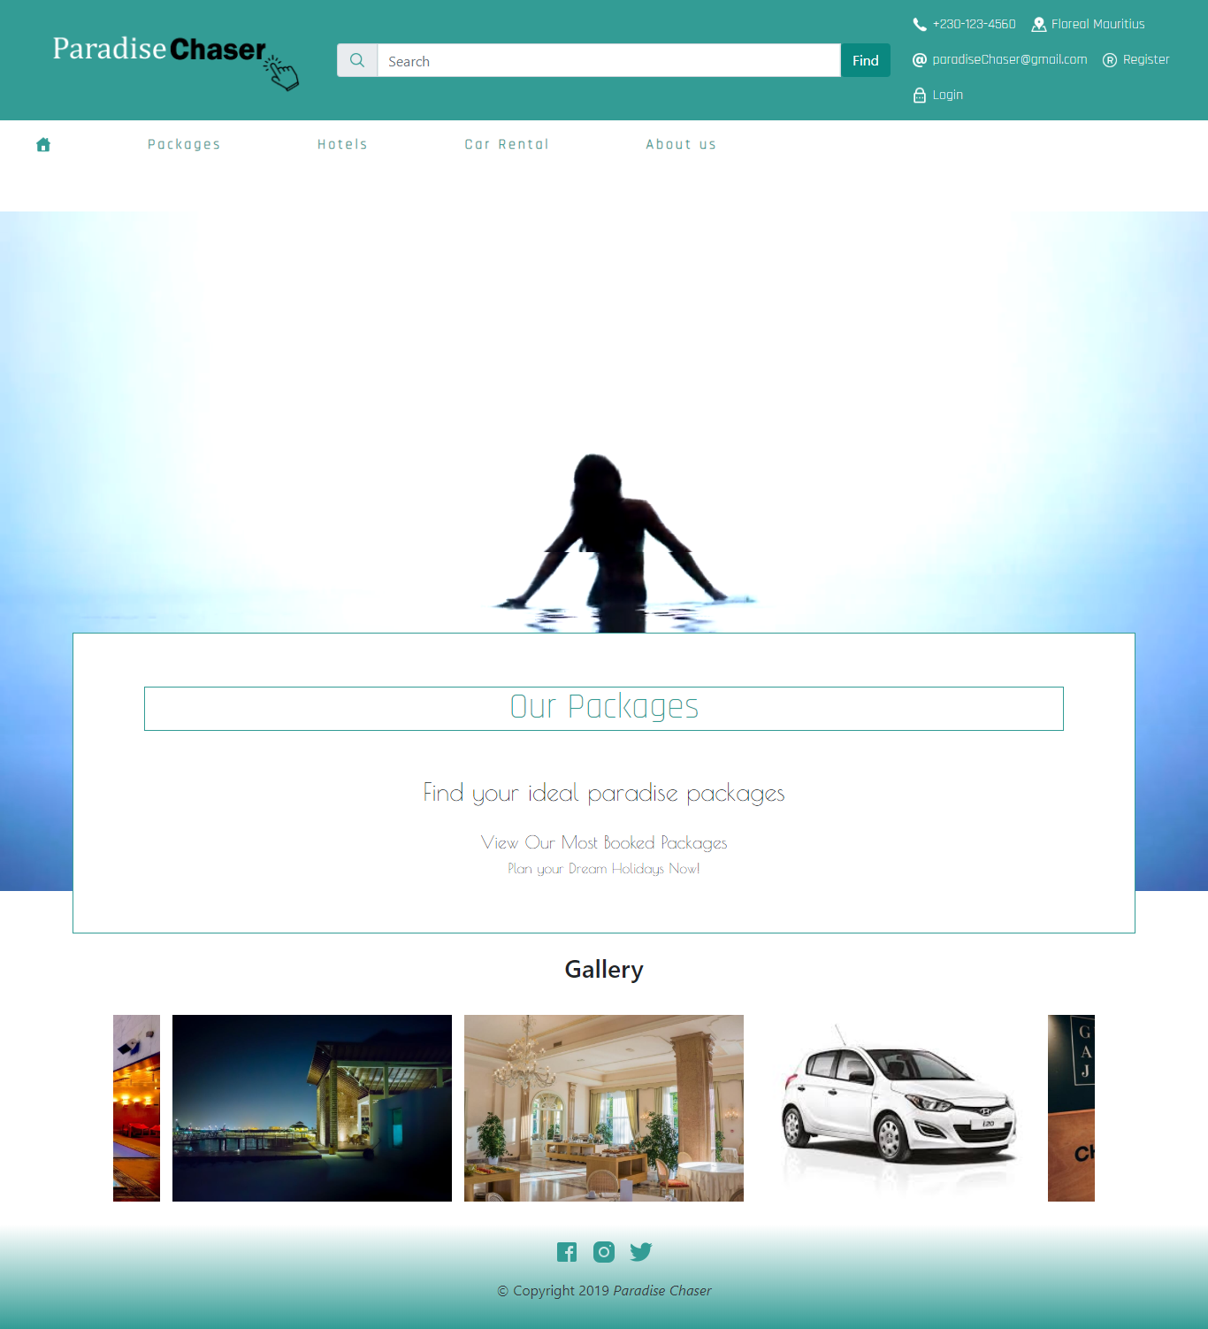

**Customer Section**

Steps: For new members

1. Register
   1. 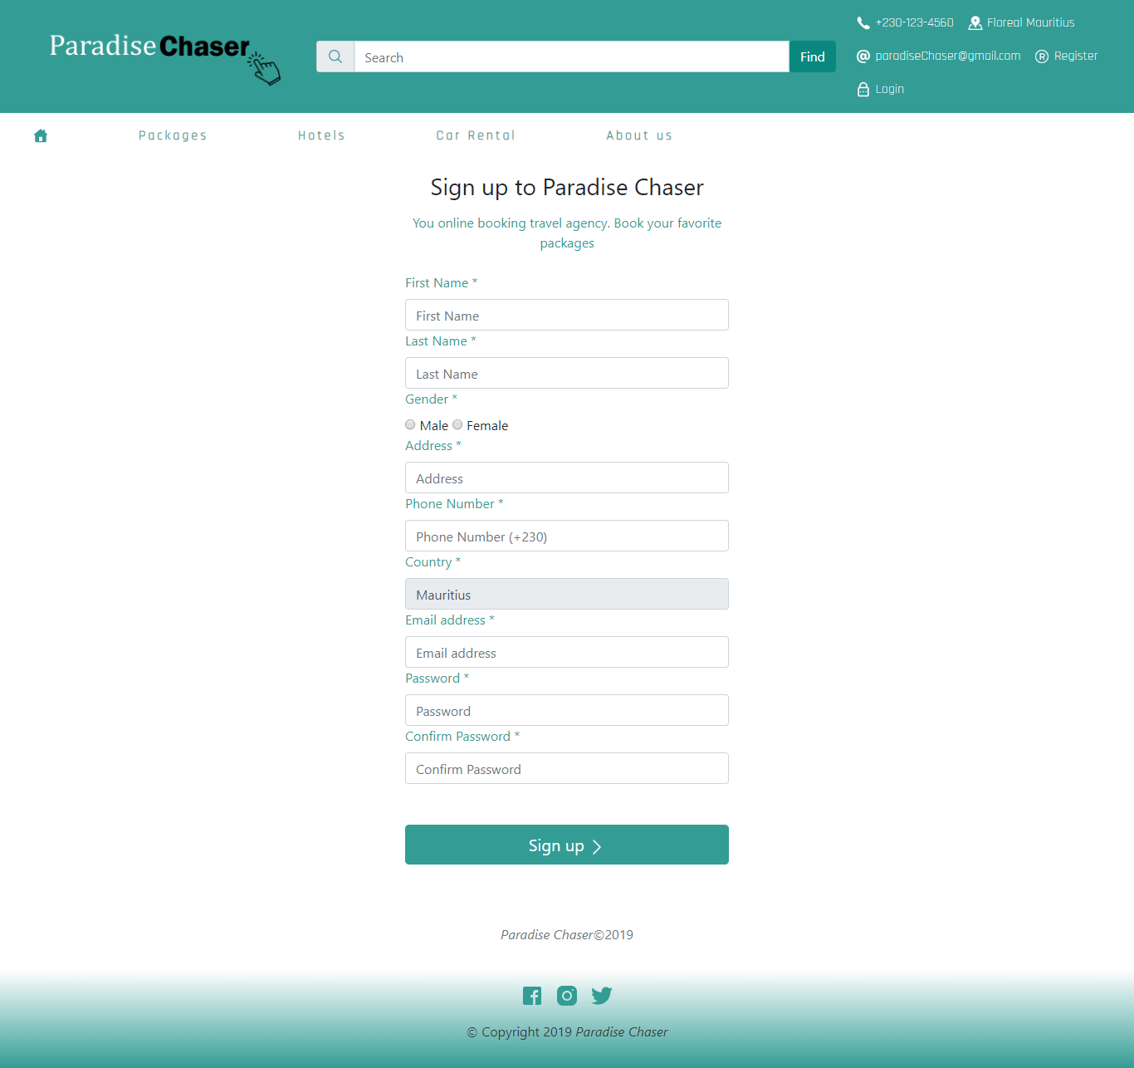Click on the registration link found on the navigation menu and the following will appear:

Kindly fill in the form with appropriate values.

After successful registration, the customer will be redirected to login page as shown below:

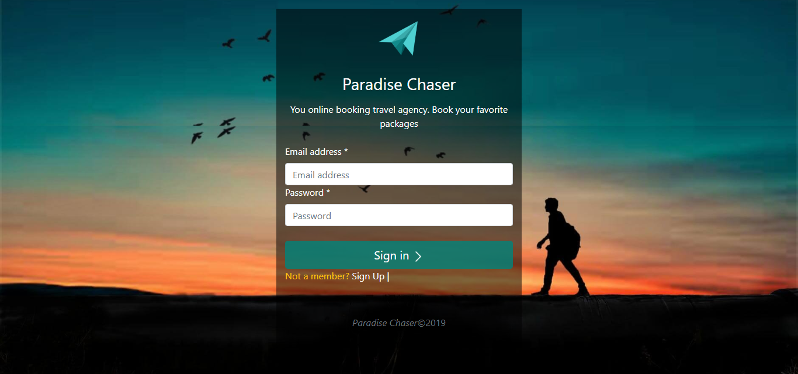

After login with valid credentials, the user will be redirected to homepage with his/her own account.

The header is changed to customer requirement including a shopping cart, a profile info and a logout button

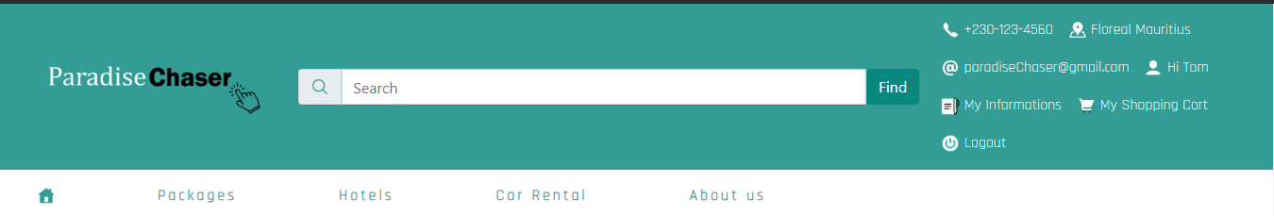

User can booked either a package typically divided in 3 parts that is a day package at a hotel, make car rental, or book a travel package to another country.

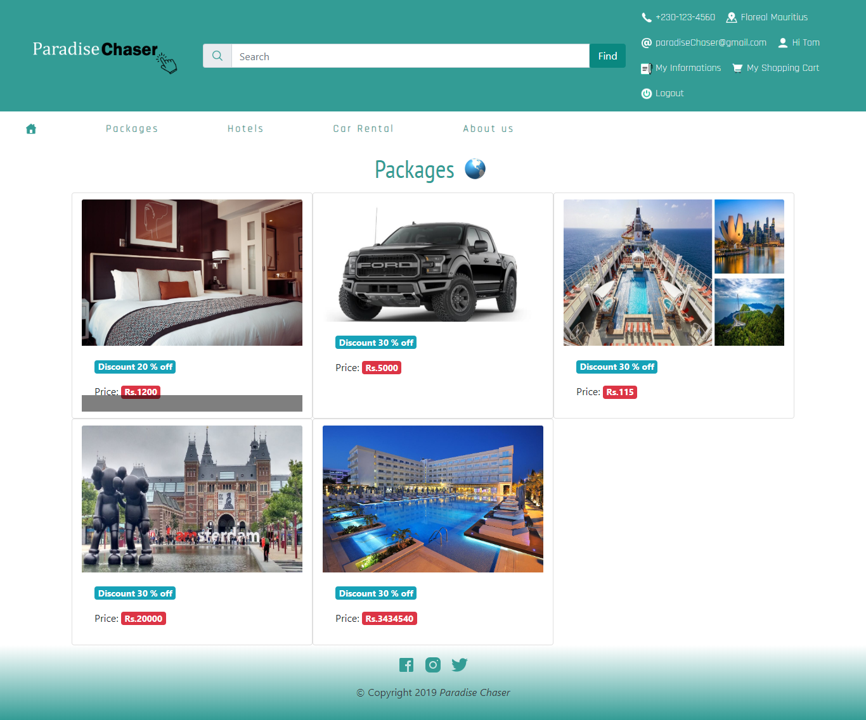

Booking example:

If a particular user wants to book a particular item from paradise chaser, the latter click on the item he/she want and the following appears depending on the package type:

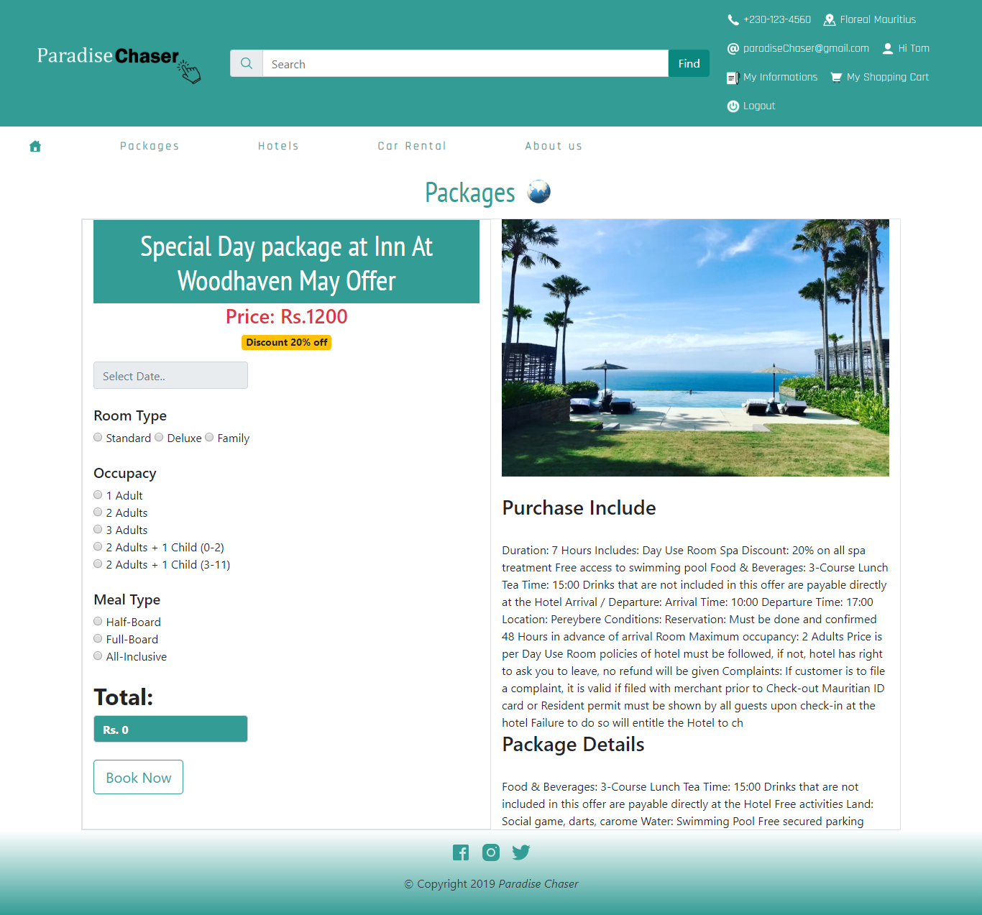

After successful booking, the item is added to the user shopping cart and upon checkout the customer is asked to select among 2 payment options as shown below:

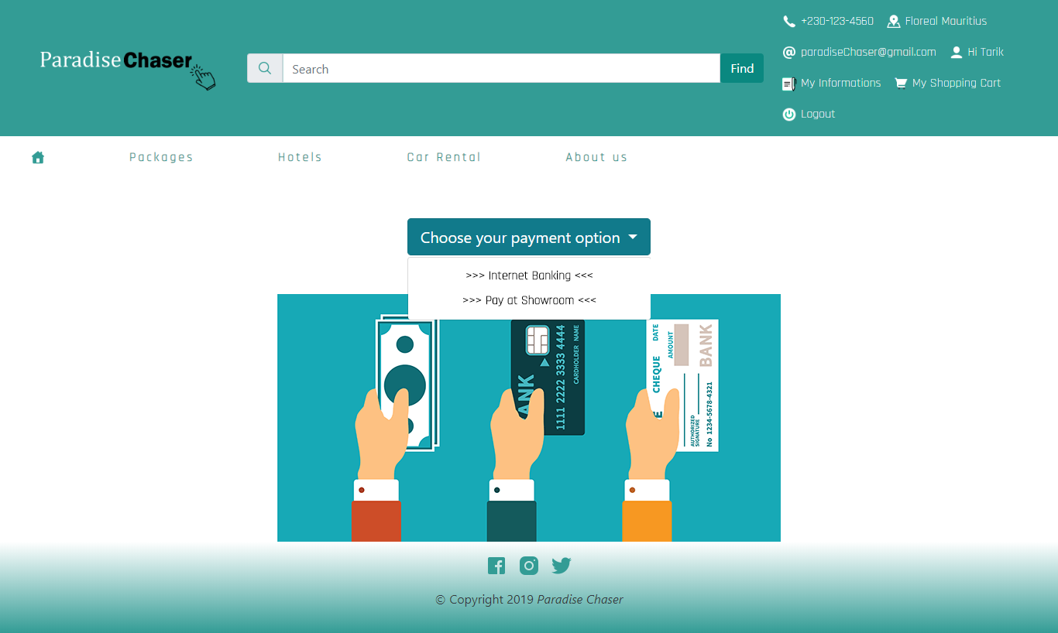

**Internet banking option**

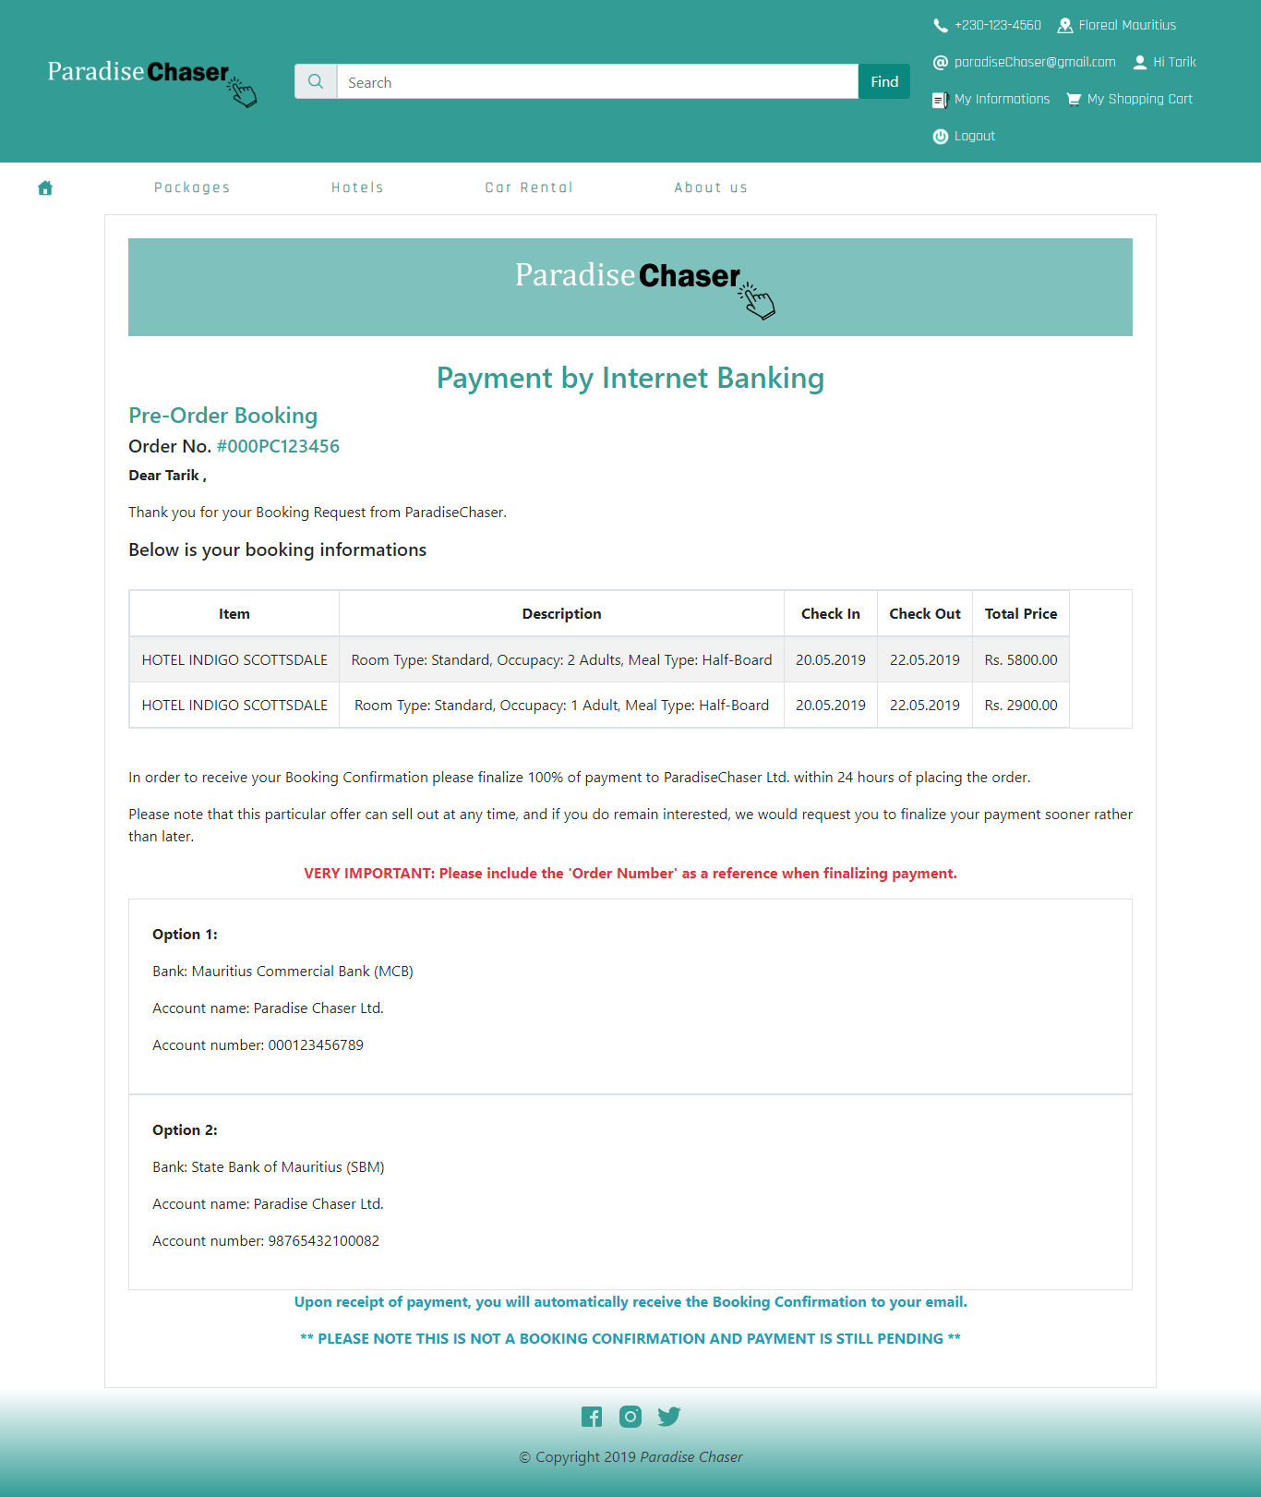

**Payment at showroom option**

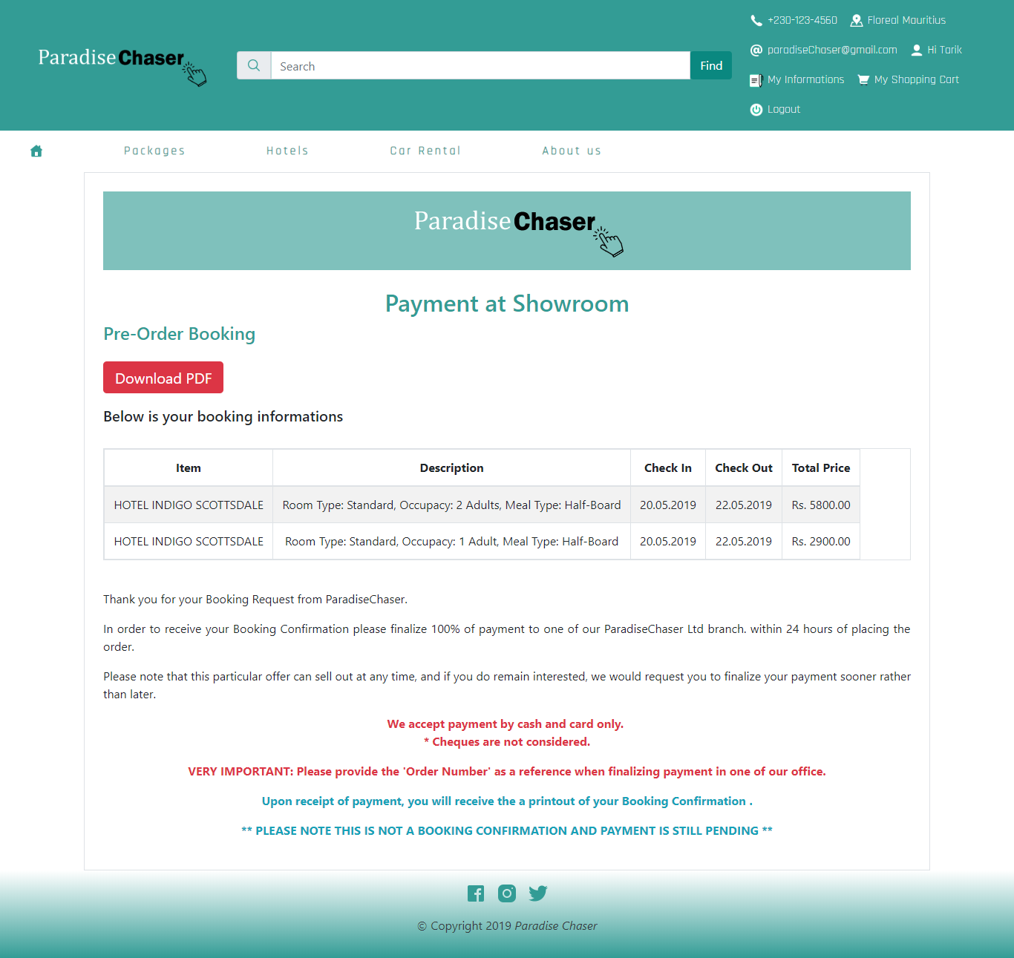

Download a PDF Version of page

After successful payment, the customer order is stored in his/her purchase history section.

**Admin Section**

Admin has the following credentials to login to the admin dashboard:

**Email: paradisechaser2019@gmail.com**

**Password: Pa$$w0rd!**

Below is a list of features that an admin can manage on the website:

1. **User**

Admin has the ability to block and unblock a customer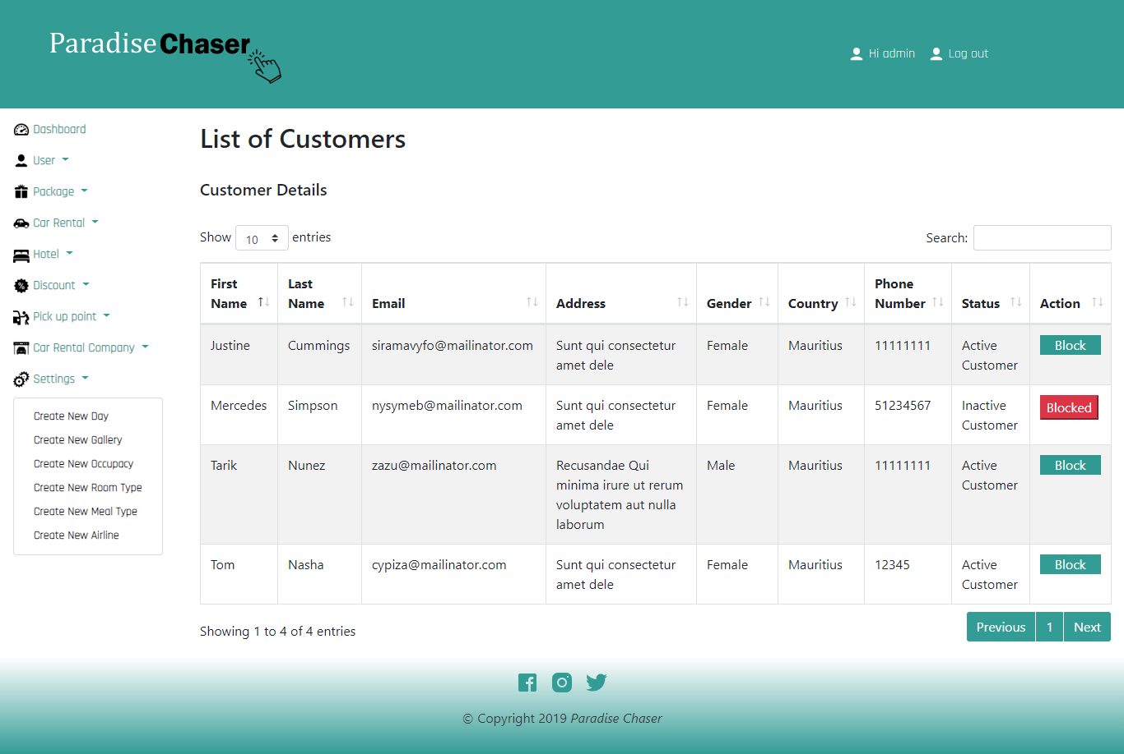.

1. Admin has the ability to add, update, remove a package, hotel or a car rental

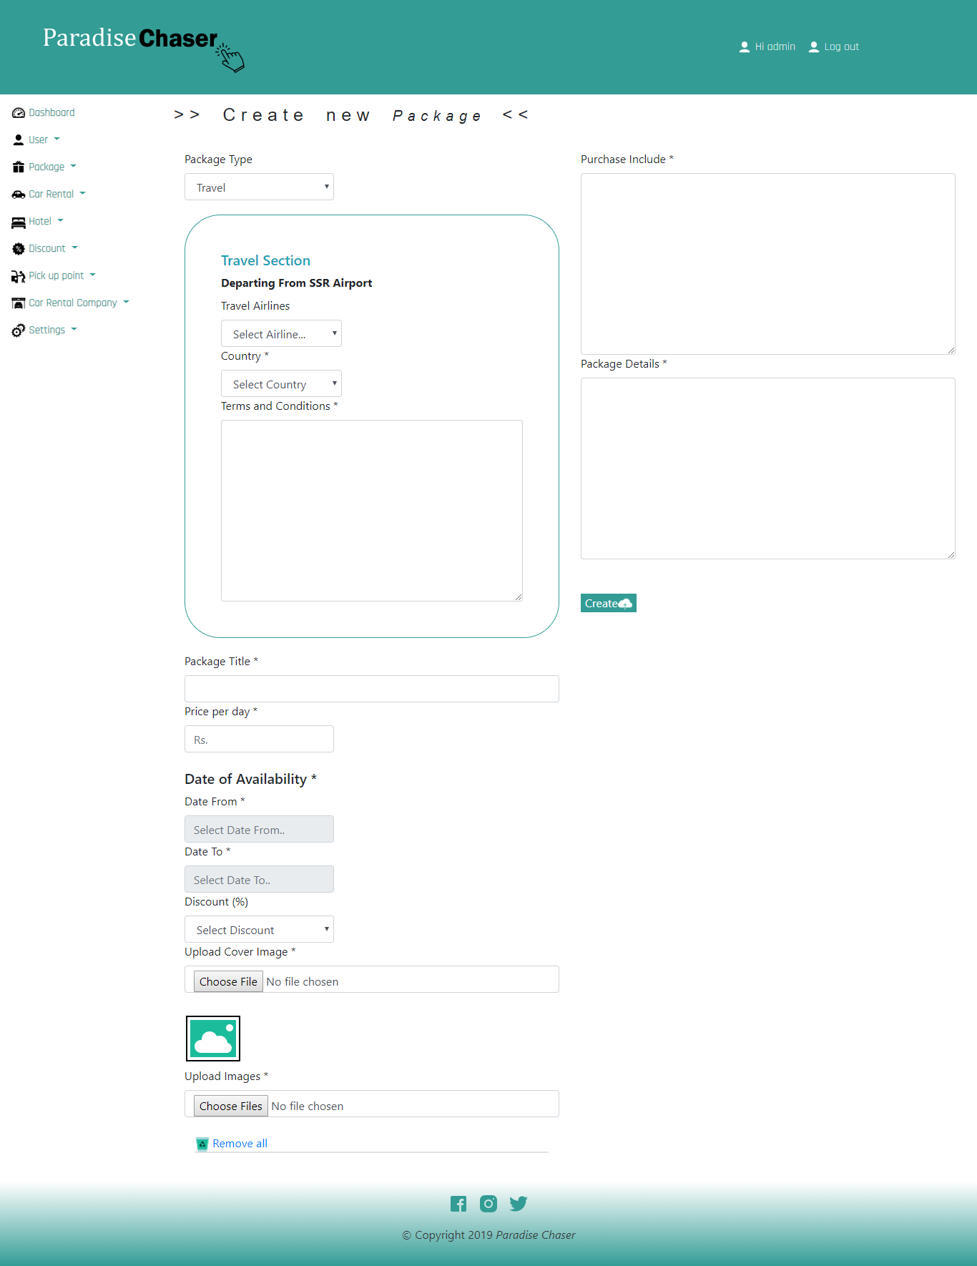

The following appear if admin selects travel

Available date for package.

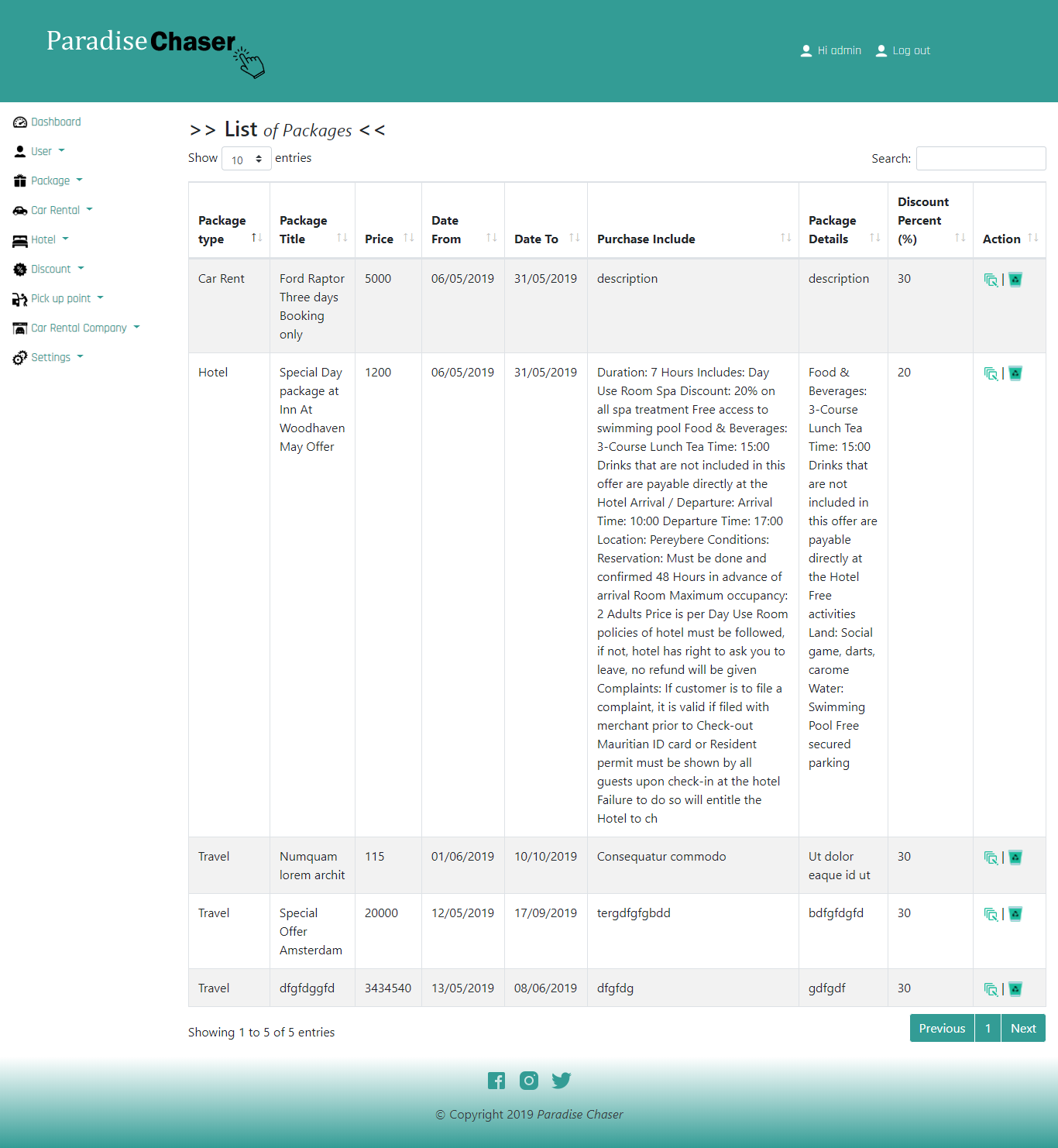

Admin also has the ability to change other settings for example pickup point

